Why was Hitler able to become Chancellor in 1933?

Hitler’s rise to power was based upon long-term factors: resentment in the German people, the weakness of the Weimar system-which he exploited through propaganda, the terror of his storm troopers, and the brilliance of his speeches. During the roaring twenties Germans ignored this vicious little man with his programme of hatred. But when the Great Depression ruined their lives, they voted for him in increasing numbers. Needing support, and thinking he could control Hitler, President Hindenburg made the mistake in January 1933 of giving Hitler the post of Chancellor.

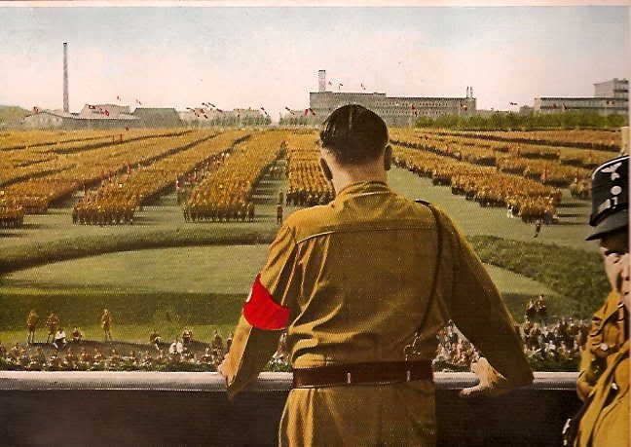
Hitler giving a major speech to the people in Germany. He was a powerful speaker and he won many votes because of that in 1932 although he did not win.

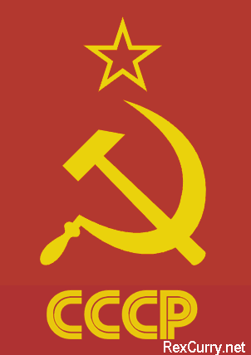
The people in Germany did not share Hitler’s views to rule the country but did share his fears. One of these fears was towards communism and this shared fear gave him a lot of votes, support and power. Also in Germany, communism was building up its party.

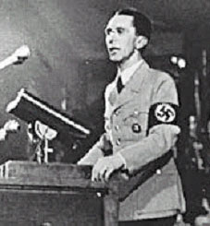
This man was Joseph Goebbels he was in charge of Nazi propaganda and was also Hitler’s right hand. He was a very intelligent man. He established Nazi campaign methods that were modern and effective, they relied on generalized slogans rather than detailed policies. The Nazis blamed the Jews, the communists and the Weimar politicians that had signed the Treaty of Versailles for Germany’s problems.

This was the Treaty 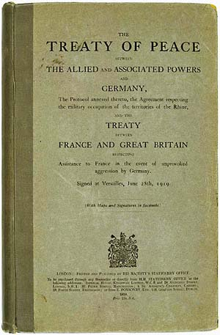 of Versailles. Hitler had promised to reverse it if he came to power. And this gave him many votes also because the Treaty of Versailles was seen as a humiliation in the German society.

The Wall Street Crash 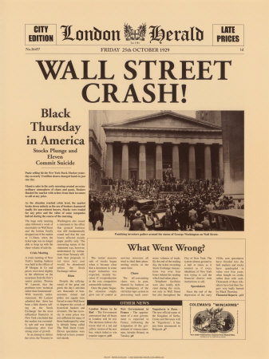caused a worldwide depression, which affected Germany harshly. Before the Wall Street Crash, the Nazis had already established their party but had not gained many votes. The depression helped Hitler to restate that Germany was going through so much trouble because of the Jews, the communist, etc, and this time he was gaining more votes in the Reichstag.

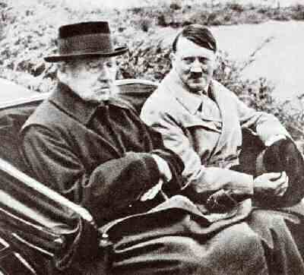

In this photo we can see Hindenburg with Hitler. Both, Hindenburg and Franz Von Papen that was the chancellor of Germany at that moment decided to appoint him as Chancellor in 1933 because they thought that they would be able to control him but they were completely wrong.

This was the Nazis celebrating that Hitler was appointed as Chancellor in 1933. 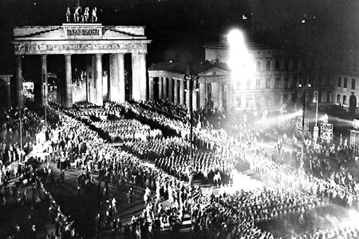 This picture shows us how he ascended to power and how many people supported him.

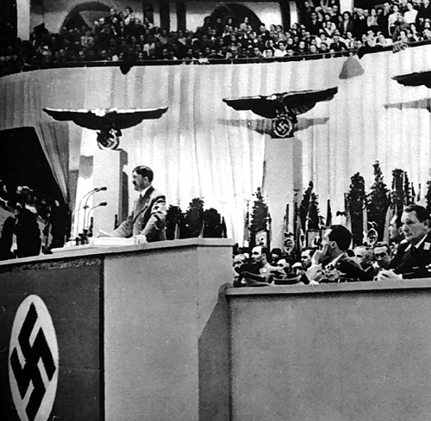

Here we have Hitler giving another major speech. This was the speech that he gave when he came to power.

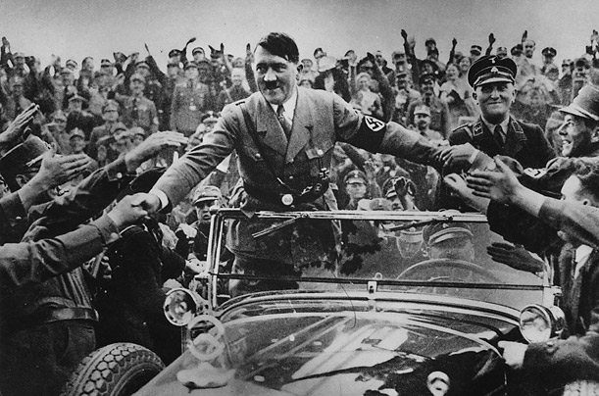Hitler being received in Germany after he was appointed as Chancellor in 1933. We can see how well people received him shaking his hand and making the Nazi salute.

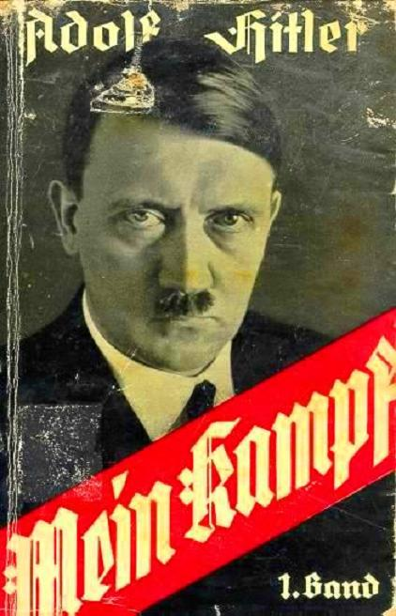Before coming to power while he was in prison after the Munich Putsch, he wrote a very important and famous book which was called Mein Kampf in which he expressed his plans for the future of Germany if he came to power. His three main aims were:
A) Abolish the Treaty of Versailles.
B) Expand the German territory.
C) Defeat communism.

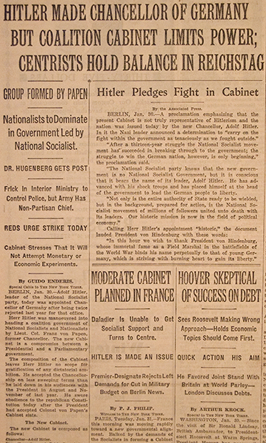

This picture is an article taken from the newspaper New York Times which shows us that Hitler came to power.

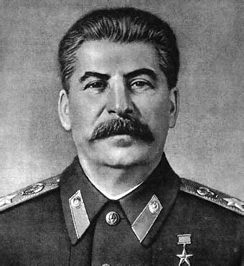
Stalin at that time, who was the leader of communism and the USSR, was Hitler’s First enemy. One of Hitler’s plans and yearnings was to defeat communism and build up an empire formed by all citizens from the Aryan race.

This picture shows us people 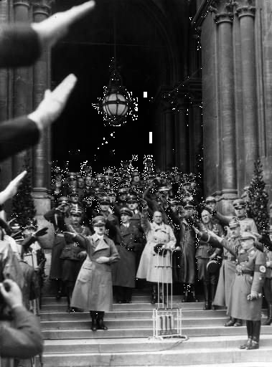saluting Hitler with the Nazis salute expressed as “heil Hitler” after becoming Chancellor and this was very important for the Nazis because with this Hitler was gaining more and more power and it was a sign of respect towards him.

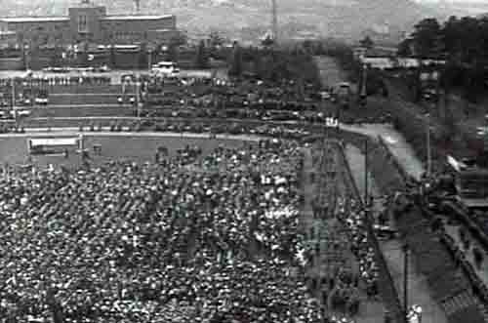 This picture shows Hitler’s campaign giving another of his powerful speeches to gain support in Italy.

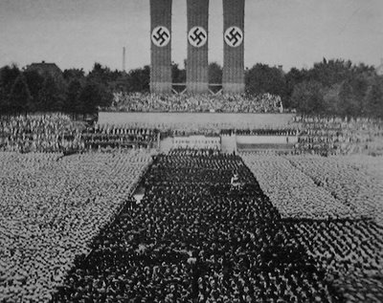
This photo shows the success of rearmament in Germany which had been prohibited by the Treaty of Versailles, Hitler with this action was reverting the Treaty of Versailles which was one of the points in his famous book Mein Kampf. Also this photo shows the success Hitler had as a Chancellor and that many people supported him.

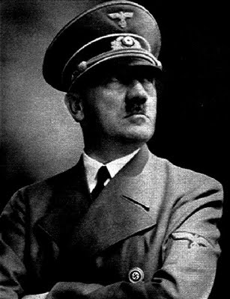
To end with, this is a picture of the fascist Nazi leader Adolf Hitler. He was a very smart and ambitious person was an Austrian born German politician and the leader of the National Socialist German Workers Party.

